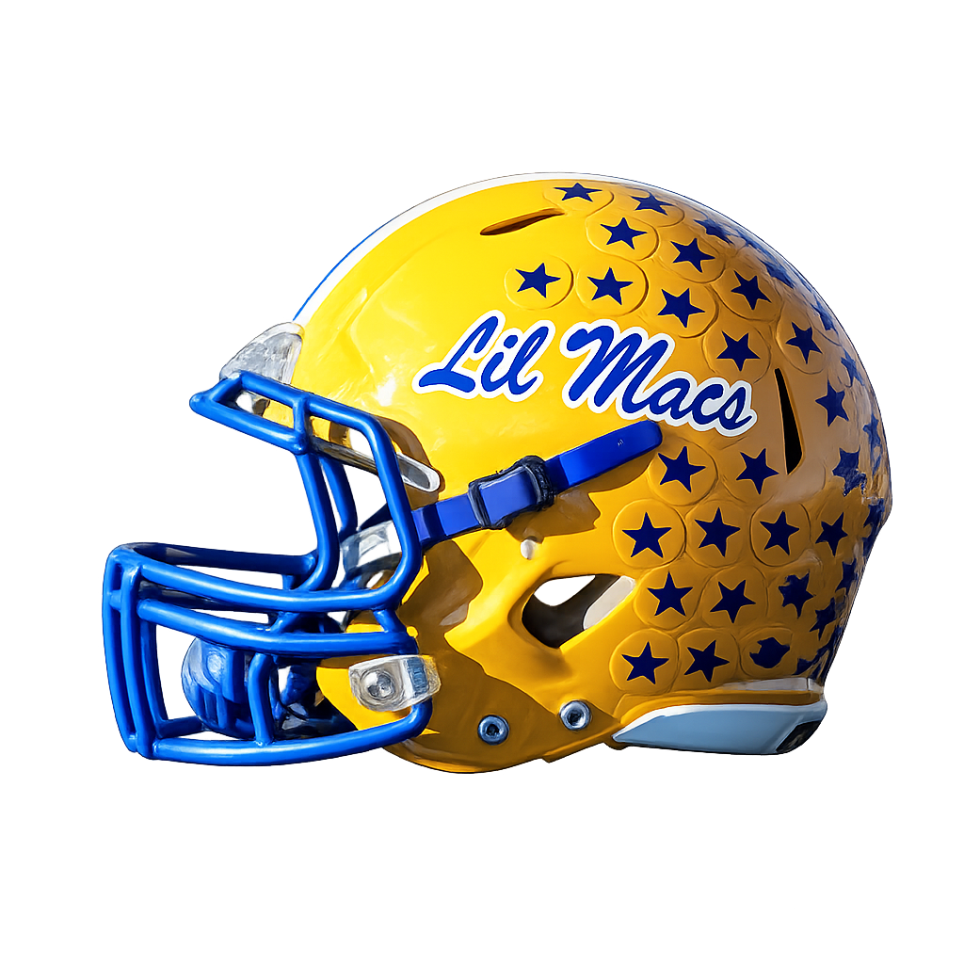
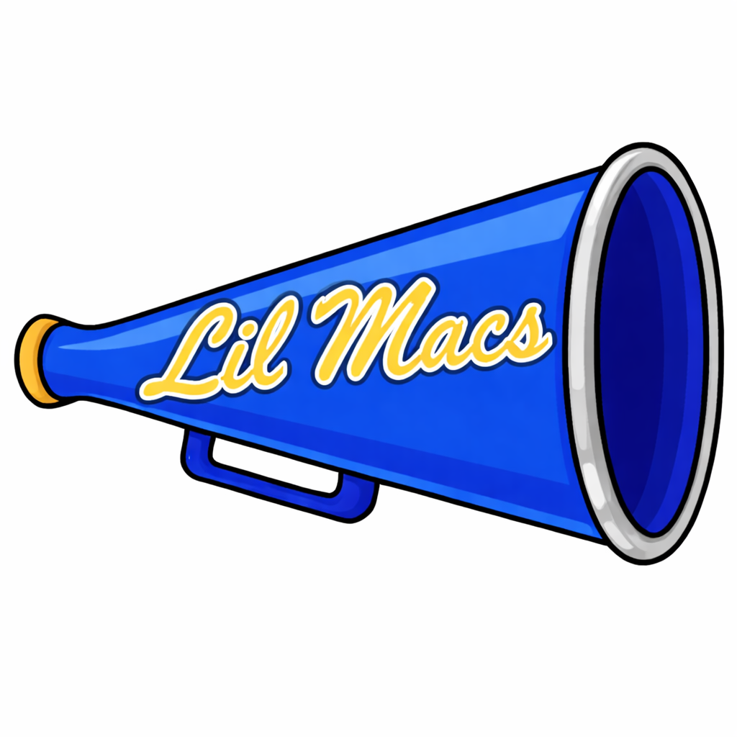
February Public Board Meeting Agenda
Canon Mac Youth Football Association

Date: Thursday, February 12, 2026
Time: 6:00pm
Location: North Strabane Township Building
Board Members in Attendance: Rodney, Nick, Jamie, Megan, Tammy, Mike

- Welcome & Call to Order:
  - Call to Order: 6:04pm

- Executive Board Updates:
  - President:
    - 112 helmets were sent out for reconditioning to Rydel
    - Starting to book food trucks for the kickoff party
    - We are finalizing dates for the league and will provide those next month
  - Vice President:
    - No Report
  - Athletic Director:
    - No Report
  - Director of Cheer:
    - Currently comparing pricing from Varsity and Keystone Custom so that we can stay competitive on prices for our cheer families
    - Keystone Custom presented us with a fundraising idea for a custom shirt, the league would get 70% of the price of the shirt, the new board will review this opportunity once they are in place
    - Working with Melinda to set cheer camp dates for July, update will be provided once we have it
    - Sideline clinics will be held in June, dates and location TBA
  - Treasurer:
    - December 2025:
      - Beginning Balance: $50,262.65
      - Deposits: $13,420.56
      - Withdrawals: $ 5,644.83
      - Ending Balance: $58,038.38
    - January 2026:
      - Beginning Balance: $58,038.38
      - Deposits: $ 0.00
      - Withdrawals: $24,327.88
      - Ending Balance: $33,710.50

- General Board Updates:
  - Flag Football Coordinator:
    - No Report
  - Director of Communications:
    - No Report
  - Concession Stand / Volunteer Coordinator:
    - No Report
  - Assistant Cheer Coordinator:
    - No Report

- Important Dates & Reminders
  - March 12, 2026: March Monthly Board Meeting at Cecil Generations Room
  - April 1, 2026: Football and Cheer Registration Opens
  - April 9, 2026: April Monthly Board Meeting at Cecil Generations Room
  - May 1, 2026: Cheer Registration Ends
  - Early May / TBD: Cheer Uniform Fittings
  - Early June: Football Registration Ends
  - June 8, 2026: League numbers due to SHYFL
  - August 9, 2026: Wild Things Game (Fundraiser – we get 50% of the ticket sales)
  - August 13, 2026: Final rosters due to SHYFL
  - August 29, 2026: Week 1 of the 2026 Season
  - October 17, 2026: First week of Playoffs (Tackle)
  - November 1, 2026: Super Bowl

- New Business
  - SHYFL Updates:
    - Open Proposals:
      - Split 5th and 6th grade into grade specific teams instead of mixed
        - If you don’t have enough 5th graders to field a team, you would have to play them as a 5th / 6th grade combined team, and they would compete at the 6th grade level
        - Splitting in this fashion will help with playing time
        - Will allow more time for those upcoming 5th graders to get comfortable and gain more experience
        - If we move to this split, is there a reason to still have the 5th quarter?
          - This is something that we could take to SHYFL and ask, but most schools like the 5th quarter, so doubtful
        - Will there be any consideration if you have a smaller 5th grade team to allow a 6th grader to play down? Maybe those who are on the smaller side or with less experience?
          - There was a discussion about allowing kids to play up, but not down
          - SHYFL in the past has voted on allowing players who are smaller to play down, but it is on a case by case scenario
      - Split 3rd and 4th grade into grade specific teams instead of mixed
        - Other schools don’t feel that they will have enough children in each grade to split at this level
      - If the 5th and 6th grade level splits into grade specific teams, there is a possibility that the 6th grade team will increase the max weight
    - SHYFL has changed that all game films MUST be filmed from above, it cannot be filmed from the field
    - SHYFL is discussing the use of AI glasses on the field, there is no rule as of this time
    - Costs Due to SHYFL:
      - $662 payment for the Super Bowl (all organizations pay for this), it is being hosted by Upper St. Clair this year
      - $100 payment for the Coaches Kickoff event
    - Next SHYFL meeting: Monday, February 16, 2026

- Old Business
  - Press Box
    - Sponsorships:
      - Currently we have received sponsorships from:
        - TJD Energy Services, LLC ($500.00)
        - Range Resources ($2,500.00)
      - We still have requests out to: Clearview, Dick’s Sporting Goods, JB Life, Washington Chevy, and CNX
      - If you know of anyone who would like to donate to help us rebuild the press box, please reach out to Tammy or Nick
    - We will be working to get 2-3 quotes for the work with the hope of breaking ground once spring comes
  - Elections:
    - Open Positions:
      - Vice President
      - Secretary
      - Tackle Coordinator
      - Flag Coordinator
      - Assistant Flag Coordinator
      - Communications Coordinator
      - Concession Stand / Volunteer Coordinator
    - Process:
      - Rodney will send out a link for voting for open positions on Friday, February 13, 2026. Voting will close on Monday, February 16, 2026. An email will be sent out once votes are tallied to introduce the new board members.
    - Rodney opened up the floor to questions about the voting process
      - Who is eligible to vote?
        - Rodney ran through the list of those who are eligible to vote

- Open Floor / Member Questions
  - A coach has a parent who reached out about turning in their tackle players uniform, the coach will pick it up from the parent and turn it into Rodney
  - How are we getting information out about the flag program opening up to include 5th and 6th graders this year?
    - Discussed that we can make a flyer and send it to the school to distribute and that we can post them out in the community and to social media
    - We are open to any ideas that anyone has
  - A coach asked about getting Hudl Assist through Hudl for game film?
    - Rodney said that we currently pay $400, the coach said this would be an additional $400 cost
    - Rodeny said he will check with SHYFL

- Closing Remarks & Adjournment
  - Closing Remarks:
    - Please keep in mind that once we send out the election results, we will be wiping the system to prepare for the new season. Once we do that, we are no longer able to send out emails. We will post important information to the website and social media.
    - All board meetings will be held on the 2nd Thursday of the month at 7pm unless otherwise announced.
    - Nick requested that when you register for the upcoming season please include a secondary email address so that we can ensure everyone is receiving the leagues emails.
  - Next Meeting Date: Thursday, March
  - Adjournment: 6:37pm (called by Rodney, 2nd by Nick)

CMYFA Board Meeting Attendance:
Justin Corso
Jaime Corso
Rose Martin
Mike Martin
Nicole Skinner
Brittany Thomas
Todd Shulsky
Bryan Corkery
Brynnly Schwartz
Jeremy Metz
Andrew Shinsky
Mike Juskowich
Megan Jeremiah
Jamie Mills
Nick Jeremiah
Rodney Davis
Mike McCarthy
Mike Ronshousen
Erin Fostyk
Monnisa Alderson
Thomas Alderson
Matt Cox
Paige Angle
Dave Angle
Tammy Sampson

